# Assignment #6 – Machine Learning – Professor Haugh

## **Jaime Gacitua**

## **jg3499**

## **Due Wednesday April 06, 2016**

## Question 1

Demonstrating by induction,

Base case $i=1$:

The optimization model is,

$$\max_{a}{Var\left(a^{T}x\right)} \\ \begin{matrix}subject to & a^{T}a=1 \\ & \end{matrix}$$

The Lagrangean is,

$$L\left(a,λ\right)=Var\left(a^{T}x\right)+λ(1-a^{T}a)$$

Differentiating and equaling to zero, to find the maximizer,

$$\frac{dL}{da}=Σa-λa=0 \\ Σa=λa$$

This is the equation that solves for the Eigen-value $λ$ and Eigen-vector $a=γ_{1}$, therefore for the base case, the proposed model solves for $γ_{1}$.

Base case $i=2$:

The optimization model corresponds to

$$\max_{a}{Var\left(a^{T}x\right)} \\ \begin{matrix}subject to & a^{T}a=1 \\ & a^{T}γ_{1}=0\end{matrix}$$

The Lagrangean is,

$$L\left(a,λ,μ\right)=Var\left(a^{T}x\right)+λ\left(1-a^{T}a\right)-μ_{1}a^{T}γ_{1}$$

Differentiating and equaling to zero,

$$\frac{dL}{da}=Σa-λa-μ_{1}γ_{1}=0$$

### Question 2

1. Optimizing Z for fixed B, the model to optimize is

$$\min_{Z}{\sum_{i=1}^{n}{\sum_{j=1}^{d}{γ_{j,i}}{\left[x_{j,i}-\sum_{k=1}^{M}{z_{k,i}b_{j,k}}\right]}^{2}}}$$

Calculating the first order conditions,

$$\sum_{j=1}^{d}{γ_{j,i}\left(x_{j,i}-\sum_{l=1}^{M}{z_{l,i}{\hat{b}}_{j,l}}\right){\hat{b}}_{j,k}}=0 ∀ i=1,…,n$$

Having $B$ constant, for each $i=1,…,n$, we have a system of $M$ equations, defined by the vector of equations above.

It is not a problem is the system of equations is under-determined (there are less observations in the nth data column of X than there are components of B). We can use the pseudo-inverse of the matrix to provide a minimal solution.

1. Optimizing for B for fixed Z, the first order conditions yield,

$$\sum_{i=1}^{n}{γ_{j,i}\left(x_{j,i}-\sum_{l=1}^{M}{{\hat{z}}_{l,i}b_{j,l}}\right){\hat{z}}_{k,i}}=0 ∀ j=1,…,d$$

Having $Z$ constant, for each $j=1,…,d$, we have a system of $M$ equations, defined by the vector of equations above.

1. To code the function, I will use the following logic to construct the systems of equations.

For the first step, create $i=1,…,n$ systems of equations, of size M, of the form $c^{(i)}=M^{(i)}z^{(i)}$, where

$${\left[z^{\left(i\right)}\right]}_{l}=z_{l,i} \\ {\left[M^{\left(i\right)}\right]}_{kl}=\sum_{j=1}^{d}{γ_{j,i}}{\hat{b}}_{j,l}{\hat{b}}_{j,k} \\ {\left[c^{\left(i\right)}\right]}_{l}=\sum_{j=1}^{d}{γ_{j,i}x_{j,i}{\hat{b}}_{j,l} }$$

For the second step, create $j=1,..,d$ systems of equations of the form $m^{(j)}=F^{(j)}b^{(j)}$, where

$${\left[b^{\left(j\right)}\right]}_{l}=b_{j,l} \\ {\left[F^{\left(j\right)}\right]}_{kl}=\sum_{i=1}^{n}{γ_{j,i}}{\hat{z}}_{l,i}{\hat{z}}_{k,i} \\ {\left[m^{\left(j\right)}\right]}_{l}=\sum_{i=1}^{n}{γ_{j,i}x_{j,i}{\hat{z}}_{l,i} }$$

The convergence criteria will be based on parameter $ϵ$. Let $Z_{i,j}^{\left(t\right)}, B_{i,j}^{\left(t\right)}$ represent the elements of Z and B on iteration t.

We will stop iterating when,

$$Convergence=\sum_{k,i}{{\left(Z_{k,i}^{t+1}-Z_{k,i}^{t}\right)}^{2}}+\sum_{j,k}{{\left(B_{j,k}^{t+1}-B_{j,k}^{t}\right)}^{2}}≤ϵ$$

## Question 3

1. To make the problem manageable, I decided to use $d=300$ users, $n=600$ movies, and will apply the formulas with total number of PCA dimensions $M=5$.

The data matrix $x$, has shape $d x n$: the users is the dimensionality of the dataset, and n as number of observations.

The initial basis $B^{0}$ was chosen as $B_{i,j}^{0}=\left\{\begin{matrix}1 & if j=(i mod(M))+1 \\ 0 & \sim \end{matrix}\right.$

The tolerance criteria was set at $ϵ=1$. The tolerance indicator is detailed in question 2.(c).

The script took $1168\left[s\right]≈20[min]$ to run. **The RMSE is 24549.7**

The output of the script was the following:

[1] "Starting Iterations"

[1] "-----------"

Iteration = 1

Tolerance = 1

Convergence = 2900.13

RMSE = 24577.08

Iteration Time = 30.21 0 30.26 NA NA

Total Time = 30.21 0 30.26 NA NA

[1] "-----------"

Iteration = 2

Tolerance = 1

Convergence = 22099.94

RMSE = 24567.16

Iteration Time = 27.4 0 27.47 NA NA

Total Time = 57.61 0 57.73 NA NA

[1] "-----------"

Iteration = 3

Tolerance = 1

Convergence = 1407.341

RMSE = 24558.37

Iteration Time = 30.2 0 30.36 NA NA

Total Time = 87.81 0 88.09 NA NA

[1] "-----------"

… Iteration 4 to 36…

Iteration = 37

Tolerance = 1

Convergence = 1.296265

RMSE = 24549.54

Iteration Time = 32.06 0 32.17 NA NA

Total Time = 1116.56 0.24 1120.51 NA NA

[1] "-----------"

Iteration = 38

Tolerance = 1

Convergence = 1.13819

RMSE = 24549.62

Iteration Time = 29.52 0 29.58 NA NA

Total Time = 1146.08 0.24 1150.09 NA NA

[1] "-----------"

Iteration = 39

Tolerance = 1

Convergence = 0.9894758

RMSE = 24549.7

Iteration Time = 22.34 0 22.34 NA NA

Total Time = 1168.42 0.24 1172.43 NA NA

1. I ran the code with $K=15$ different starting points. We can clearly reach better local minima if we try different starting points, therefore this must be of recurring practice in the industry. On the other hand, I see that this is a very intensive task from a computational standpoint.

This process took is around 5 hours of computer time.

I generated the random initial basis drawing each element of the matrix from a standard normal distribution.

The RMSE obtained are in the following list, and plotted below.

> RMSE

[1] 24551.40 24549.45 24551.20 24550.71 24546.27 24551.41 24549.14 24551.11 24550.60 24547.82 24546.10 24543.92 24547.64

[14] 24546.05 24548.29

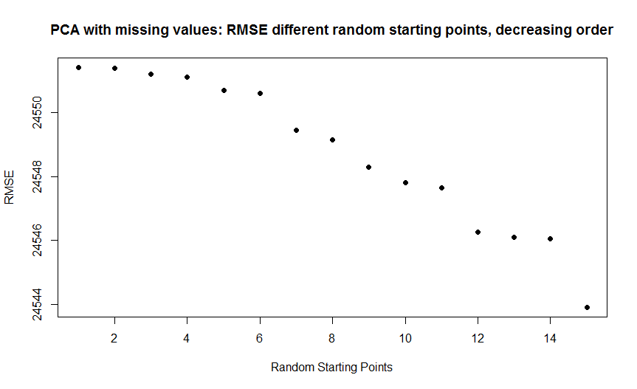

1. Using this code,

The output matrix $\hat{B}$ is an approximation for the first $M=5$ columns of the matrix of factor loadings, in the lecture notes represented with the Greek Letter $Γ$.

The output matrix $\hat{Z}$ is an estimated reconstruction of each data point in the PCA space.

To estimate the full matrix of ratings of $Users x Movies$, which we will call $R$, we can do

$$\hat{R}≈\hat{B}⋅\hat{Z}$$

If we want to look at movies to recommend to user $d$,

1. Extract the $d^{th }$ row of the matrix $\hat{R}$, represented as ${\hat{R}}_{i,⋅}$ This is a row vector of dimension n.
2. We create a new row vector $r_{d}$, containing only the unrated movies. We would calculate it with pair-wise multiplication, for each movie $i$ as follows,
$${\left(r_{d}\right)}_{i}={\hat{R}}_{d,i}⋅(1-γ_{d,i})$$

$$(r_{i})$$

3. Within this subset, recommend the movies with the highest rating.

**If we want to recommend a movie of a specific genre, using the definition of matrix $G_{i,j}$, add two steps:**

1. If we want to recommend a specific genre $\overline{g}$ to user $d$, we get the column vector $G_{⋅,\overline{g}}$, and make pairwise multiplication,

$${\left(r_{d}\right)}_{i}←{\left(r_{d}\right)}_{i}⋅G_{i,\overline{g}} ∀i∈N$$

Recall that $N$ is the set of movies.

1. The final vector represents all the recommended movies $i$ from genre $\overline{g}$, for user $d$.

## Question 4

1. I wrote the code that can be found in the appendix. The function I wrote is callable through the following syntax:

pageRank(connections, epsilon, start.vector, convergence)

* Connections: square matrix of length d, containing 0’s and 1’s. The 1’s indicate that webpage of row $i$ has a link to page of column $j$.
* Epsilon: scalar value that allows to have an irreducible matrix
* Start.vector: Row vector of size d, to stat off the iterations.
* Convergence: stopping criteria for the iterations

1. The resulting vector with $ϵ=0.15$ is displayed below. The output makes a lot of sense, for example:

* Page 3 has the highest rank, and it makes sense because it has the highest amount of inbound links.
* Page 1 has a very high rank, similar to Page 3, because it is basically the only page leading out of 3.
* Pages 4 and 6 have the lowest rank, and we can see that they have no inbound links.

> pi

[,1] [,2] [,3] [,4] [,5] [,6]

[1,] 0.3538667 0.1860446 0.3744637 0.025 0.035625 0.025

1. The impact of $ϵ$ is extremely relevant. I solved the model for values of $ϵ$ ranging from 0.1 to 1, in steps of 0.5.

The resulting vectors are represented below, as numbers, and as colors.

* When epsilon is close to zero, the webpage links are relevant.
* The closer we get to $ϵ→1$, the values for the limiting probabilities are more similar to each other.
* At $ϵ=1$, all of the pages have the same rank.

> pi.matrix

[,1] [,2] [,3] [,4] [,5] [,6]

[1,] 0.3690412 0.1902649 0.3831939 0.01666667 0.02416667 0.01666667

[2,] 0.3538667 0.1860446 0.3744637 0.02500000 0.03562500 0.02500000

[3,] 0.3390041 0.1822408 0.3654218 0.03333333 0.04666667 0.03333333

[4,] 0.3243365 0.1789440 0.3560946 0.04166667 0.05729167 0.04166667

[5,] 0.3100062 0.1760022 0.3464916 0.05000000 0.06750000 0.05000000

[6,] 0.2960187 0.1735199 0.3365031 0.05833333 0.07729167 0.05833333

[7,] 0.2823941 0.1713934 0.3262125 0.06666667 0.08666667 0.06666667

[8,] 0.2691870 0.1696405 0.3155475 0.07500000 0.09562500 0.07500000

[9,] 0.2564290 0.1682739 0.3044637 0.08333333 0.10416667 0.08333333

[10,] 0.2441521 0.1672259 0.2929970 0.09166667 0.11229167 0.09166667

[11,] 0.2324352 0.1664768 0.2810880 0.10000000 0.12000000 0.10000000

[12,] 0.2213324 0.1660213 0.2686879 0.10833333 0.12729167 0.10833333

[13,] 0.2108980 0.1658082 0.2557938 0.11666667 0.13416667 0.11666667

[14,] 0.2012329 0.1657715 0.2423706 0.12500000 0.14062500 0.12500000

[15,] 0.1923533 0.1659000 0.2284133 0.13333333 0.14666667 0.13333333

[16,] 0.1843698 0.1661194 0.2138858 0.14166667 0.15229167 0.14166667

[17,] 0.1773750 0.1663687 0.1987562 0.15000000 0.15750000 0.15000000

[18,] 0.1714427 0.1665781 0.1830208 0.15833333 0.16229167 0.15833333

[19,] 0.1666667 0.1666667 0.1666667 0.16666667 0.16666667 0.16666667

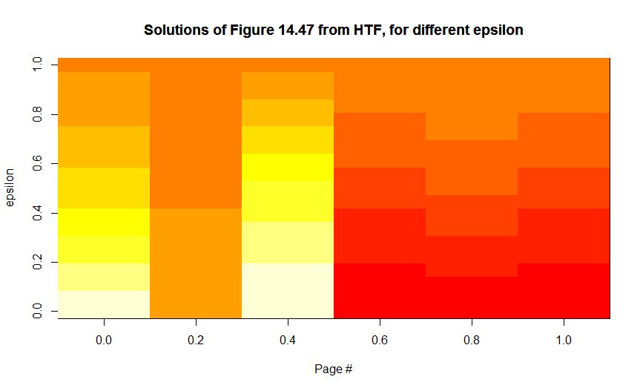

# Appendix

## Code for Q2

PCA_missing <- function(numBasis, data, data.avail, tolerance, startB){

library("corpcor")

# On the data matrix, the rows are the features, and columns are the observations.

# Get n = columns of X (number of data points)

n = ncol(data)

# Get d = rows of x (number of features, dimension of x)

d = nrow(data)

# Initialize matrices

Z <- mat.or.vec(numBasis,n)

B <- mat.or.vec(d,numBasis)

B <- startB

cat('Starting Iterations\n')

convergence <- 1000000

iter <- 1

ptm <- 0

ttm <- proc.time()

while (convergence > tolerance) {

ptm <- proc.time()

cat("-----------\n")

cat('Iteration = ', iter, "\n")

## First Step, solve i = 1,...,n systems of equations with B fixed. We get Z.

for (i in 1:n){

# System of equations M_i * z_i = c_i

# Define the matrix M_i

M <- mat.or.vec(numBasis, numBasis)

for (k in 1:numBasis){

for (l in 1:numBasis){

# Sum over dimension of x

for (j in 1:d){

M[k,l] <- M[k,l] + data.avail[j,i]*B[j,l]*B[j,k]

}

}

}

# Define the vector c_i

c <- mat.or.vec(numBasis,1)

# Sum over dimension of x

for (l in 1:numBasis){

c[l] = 0

# Sum over dimension of x

for (j in 1:d){

if (data.avail[j,i] == 1) {

c[l] <- c[l] + data.avail[j,i]*data[j,i]*B[j,l]

}

}

}

# Save z.old

Z.old <- Z

# Solve for z_i

# print("M = ")

# print(M)

# cat("c = ", c, "\n")

Z[,i] <- pseudoinverse(M) %*% c

# print("Z = ")

# print(Z)

}

## Second Step, solve j = 1,...,d systems of equations with Z fixed. We get B.

for (j in 1:d){

# System of equations F_j * b_j = m_j

# Define the matrix F_j

Fmat <- mat.or.vec(numBasis, numBasis)

for (k in 1:numBasis){

for (l in 1:numBasis){

# Sum over dimension of x

for (i in 1:n){

Fmat[k,l] <- Fmat[k,l] + data.avail[j,i]*Z[l,i]*Z[k,i]

}

}

}

# Define the vector c_i

m <- mat.or.vec(numBasis,1)

# Sum over dimension of x

for (l in 1:numBasis){

# Sum over dimension of x

for (i in 1:n){

if(data.avail[j,i] == 1){

m[l] <- m[l] + data.avail[j,i]*data[j,i]*Z[l,i]

}

}

}

# Save B.old

B.old <- B

# Solve for b_j

# B[,j] <- solve(Fmat, m)

B[j,] <- pseudoinverse(Fmat) %*% m

# print("B = ")

# print(Z)

}

# Calculate convergence criteria

# Squared difference between iteration results

convergence <- 0

for(l in 1:numBasis) {

for(i in 1:n) {

convergence <- convergence + (Z[l,n]-Z.old[l,n])^2

}

for(j in 1:d) {

convergence <- convergence + (B[j,l]-B.old[j,l])^2

}

}

iter <- iter+1

### Calculate Root-mean-squared-error (RMSE)

# RMSE Compute objective function

RMSE <- 0

temp.RMSE <- 0

for(i in 1:n){

for(j in 1:d){

if(data.avail[j,i] == 1){

for(k in 1:numBasis){

temp.RMSE <- temp.RMSE + B[j,k]*Z[k,i]

}

RMSE <- RMSE + (data[j,i]-temp.RMSE)^2

}

}

}

# RMSE Count number of observations, and divide

data.avail.count <- 0

for(i in 1:n){

for(j in 1:d){

data.avail.count <- data.avail.count + data.avail[j,i]

}

}

# RMSE Divide and apply square root

RMSE <- RMSE / data.avail.count

RMSE <- RMSE^(1/2)

### Output

# Convergence Measures

cat('Tolerance =\t', tolerance, "\n")

cat('Convergence =\t', convergence, "\n")

cat('RMSE =\t\t', RMSE, "\n")

# Timing

cat("Iteration Time =\t", proc.time() - ptm, "\n")

cat("Total Time =\t\t", proc.time() - ttm, "\n\n")

}

returnList <- list("Convergence" = convergence, "RMSE" = RMSE, "Total Time" = proc.time() - ttm,

"Basis" = B)

return(returnList)

}

## Code for Q3

source("Q2.R") # Function PCA with missing data.

# Input Parameters

num.users = 200 # Max 943

num.movies = 400 # Max 1682

num.pca.basis = 5

convergence = 1

### Prepare the database (snippet from Q2 HW5)

movies <- read.table("u.item", sep = "|", header = FALSE, stringsAsFactors = FALSE, quote="")

movies <- movies[,c(1,2)]

names(movies) <- c("movieid","movie")

rank <- read.table("u.data", sep = "\t", header = FALSE, stringsAsFactors = FALSE,

col.names = c("userid","movieid","rating","ts"))

critics <- merge(movies, rank, by = "movieid")

critics$movie <- NULL

critics$ts <- NULL

names(critics) <- c("movieid","person","rank")

### Prepare matrices

# Data matrix

data = matrix(nrow = num.users, ncol = num.movies)

gamma = matrix(nrow = num.users, ncol = num.movies)

for(i in 1:nrow(critics)) {

if (critics[i,2] <= num.users & critics[i,1] <= num.movies) {

data[critics[i,2] , critics[i,1]] <- critics[i,3]

}

}

# Gamma matrix

for(i in 1:ncol(data)){

for(d in 1:nrow(data)){

if(is.na(data[d,i]) ){

gamma[d,i] = 0

} else {

gamma[d,i] = 1

}

}

}

# Starting Basis

start.pca.basis = matrix(0, nrow = nrow(data), ncol = num.pca.basis)

# Part A

for(d in 1:nrow(data)){

start.pca.basis[d,d %% num.pca.basis + 1] = 1

}

finalB <- PCA_missing(num.pca.basis, data, gamma, convergence, start.pca.basis)

finalB

# Part B

K = 15

RMSE <- mat.or.vec(K,1)

iter = 1

for(iter in 1:K){

start.pca.basis <- matrix( rnorm(nrow(data)*num.pca.basis,mean=0,sd=1), nrow(data), num.pca.basis)

output <- PCA_missing(num.pca.basis, data, gamma, convergence, start.pca.basis)

RMSE[iter] <- output$RMSE

}

RMSE

plot(RMSE)

RMSE.sorted <- sort(RMSE, decreasing = TRUE)

plot(RMSE.sorted, pch = 19, xlab = "Random Starting Points", ylab = "RMSE",

main = "PCA with missing values: RMSE different random starting points, decreasing order")

## Code for Q4

pageRank <- function(connections, epsilon, start.vector, convergence){

d <- nrow(connections)

## Create transition matrix as Q_jk = 1/c(j)

## Where c(j) is the number of outbout links from page i

# Initialize transition matrix as zeros.

trans.mat <- matrix(0, nrow = d, ncol = d)

# Compute c(j)

c <- rowSums(connections)

# Populate transition matrix

for(j in 1:d){

for(k in 1:d){

if (connections[j,k] == 1){

trans.mat[j,k] <- 1 / c[j]

}

}

}

# Create irreductible transition matrix by adding epsilon to all elements

ones <- matrix(data = 1, nrow = d, ncol = d)

trans.mat.irr <- (1-epsilon) * trans.mat + epsilon/d*ones

# Initialize the iterating vector

mu = start.vector

mu.old = start.vector

check <- 10000

iter <- 1

while(check > convergence){

# Update mu

mu <- mu.old %*% trans.mat.irr

# Calculate convergence criteria

check <- dist(rbind(mu,mu.old))

# Record old mu

mu.old <- mu

# Output stats

cat('Done with iteration:', iter, '\n')

cat('Convergence:', check, ' / ', convergence, '\n')

iter <- iter + 1

}

return(mu)

}

connections <- matrix(c(0,0,1,1,0,0,

1,0,0,0,0,1,

1,1,0,1,1,0,

0,0,0,0,0,0,

0,0,0,0,0,1,

0,0,0,0,0,0),

nrow = 6, ncol = 6)

initial <- matrix(1/nrow(connections), nrow = 1, ncol = nrow(connections))

epsilon <- 0.15

convergence <- 0.0001

# Question b

pi <- pageRank(connections,epsilon,initial,convergence)

pi

# Question c

epsilon.values <- matrix(seq(0.1, 1, 0.05), nrow = 19)

pi.matrix <- matrix(0, nrow = nrow(epsilon.values), ncol = nrow(connections))

for(iter in 1:nrow(epsilon.values)){

pi.matrix[iter,] <- pageRank(connections,epsilon.values[iter,1],initial,convergence)

}

pi.matrix

a <-image(t(pi.matrix))

title(main = 'Solutions of Figure 14.47 from HTF, for different epsilon',

xlab = 'Page #', ylab = 'epsilon')